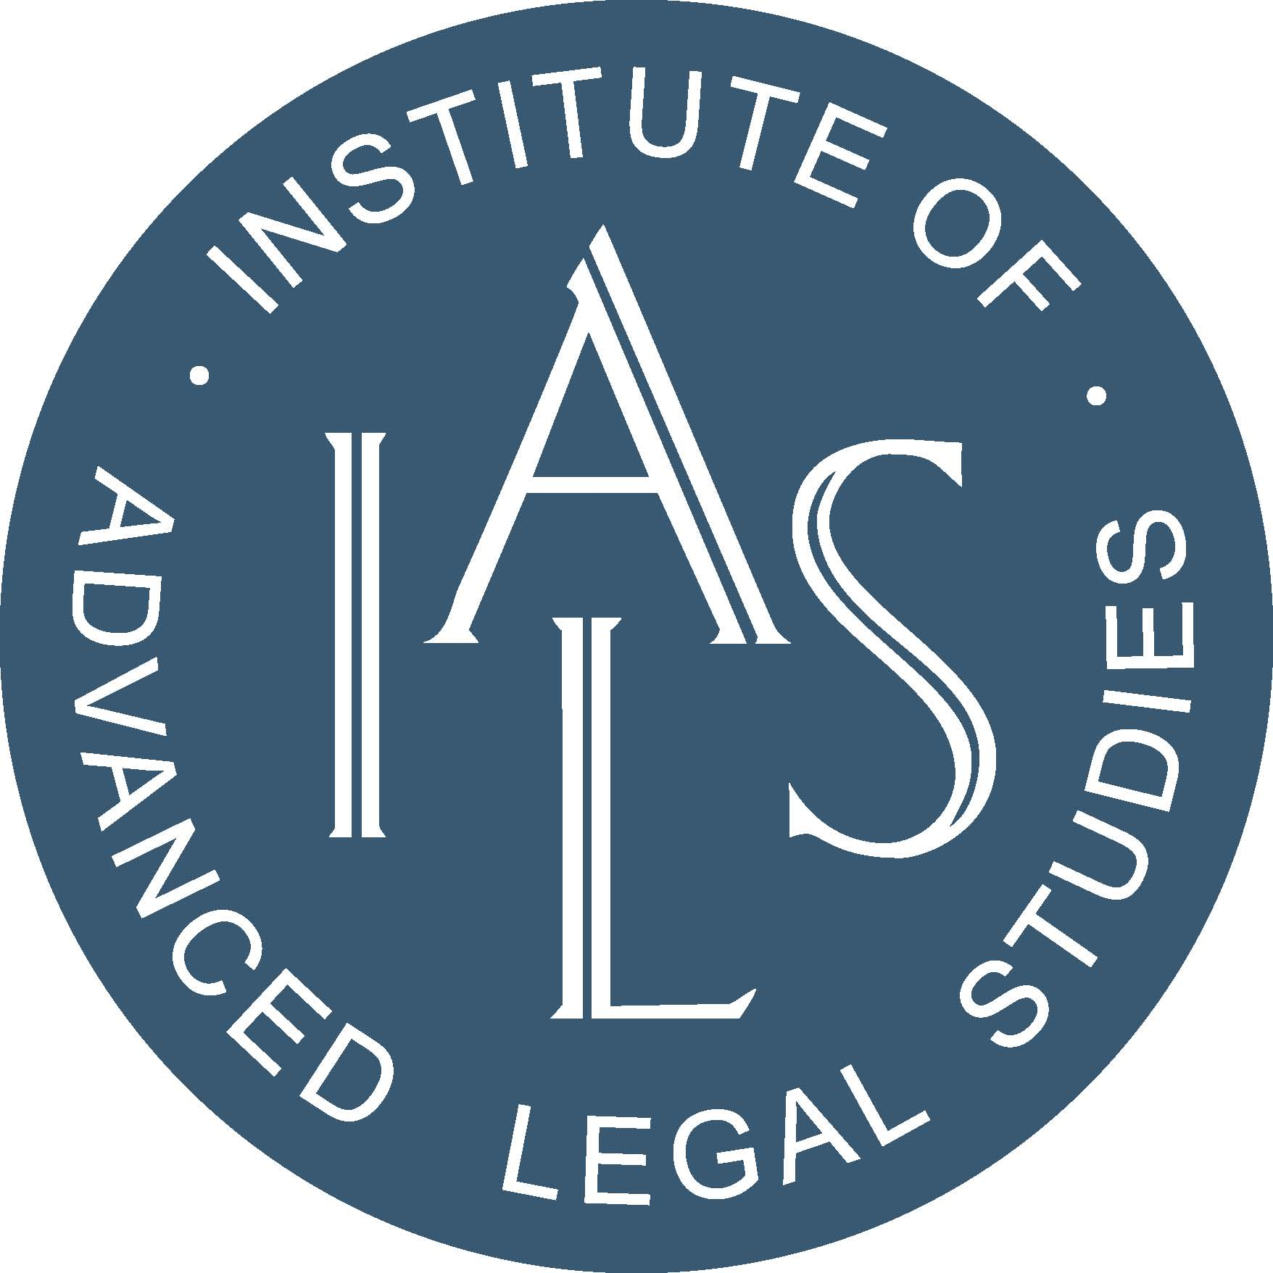
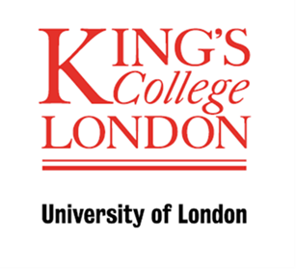

Modern Activism
27-30 June 2012, Liverpool

PROGRAMME

First day of conference: all sessions in the ADA Building, Liverpool John Moore’s University
Thereafter
A Sessions and Workshops: ADA Building, Liverpool John Moore’s University
B Sessions: Concert Room, St George’s Hall, Lime Street

9.00-10.00am Registration

10.00-11.00am Opening Cross Conference Plenary (ADA Building)
Lesley Abdela (Eyecatcher Associates): Globalising the Arguments for Gender Neutral Citizenship

11.00-11.30am Coffee

11.30-1.00pm Strand Sessions:
A Rights and Order
Stephanie Lemke (Cologne), Human Rights Lawyering - A comparative analysis of the crucial role of legal professionals in guaranteeing equal access to justice in England and Wales and Germany
Dewi Williams (Staffordshire) ‘Order in the Courts? Judicial Activism in International & Domestic Courts & Tribunals
David Lowe (LJMU), The Use of Informants in Counter-Terrorism Investigations

B History, Criminology and Activism Roundtable Discussion
Pam Cox (Essex)
Barry Godfrey (Liverpool)
Hamish Maxwell Stewart (Tasmania)

1.00-2.00pm Lunch

2.00-3.30pm Strand Sessions:
A Youth Justice in an Age of Austerity
Roger Smith, (De Montfort University) Diversion as Radical Intervention? A Brief History
Janet Jamieson (Liverpool JMU) Bleak times for children? The Anti-Social Behaviour Agenda and the Criminalisation of Social Policy
Joe Yates (Liverpool JMU) Feral Capitalism: Financial Gaming and the Youth Justice ‘Market’

B Imagining the Prison
Alyson Brown (Edge Hill): Prison tourism and the search for authenticity
Michael Fiddler (Greenwich): ‘Superstition will add to its horrors’: The reform movement and the early American Penitentiary
Helen Rogers (LJMU): tba

3.30-4.00pm Tea

4.00-5.30pm Strand Session:
A Issues of Advocacy
David Nash (OBU) Developing Legislation – Advising on Blasphemy Laws
Toby Cadman (9 Bedford Row), Advocacy and Representing Victims: The case of Syria
Lana Tatour (Warwick), Transnational Activism and the Palestinian-Arab Citizens of Israel: Empowering the Marginalised?.

B Juvenile Prisoners and Aftercare
Heather Shore (Leeds Met): ‘Reformatory School Horrors’: Investigating the Akbar Scandal in 1910
Pam Cox (Essex) & Barry Godfrey (Liverpool): Charting After
Care

2.00-5.30pm Workshop: Political Activism at Work
Academic Leader: Fran Wright and Michael Kandiah

5.45-6.45pm Strand plenaries –

Frank McDonough (LJMU): Sophie Scholl: Lessons from History in Inspiring Activism

Mike Leach: Bosque Eterno de los Ninos – the Children’s Eternal Cloud Forest.

Day Two – Thursday 28 June

9.30-10.30am Strand plenaries:

Judith Rowbotham (NTU): Reassessing Violence and Activism: the shock of the suffragettes

Hamish Maxwell-Stewart (Tasmania): Fluctuations in prosecutions and sentencing strategies in nineteenth century Tasmania

10.30-11.00am Coffee

11.00-12.30pm Strand Sessions:
A Anti-Apartheid Activism
Christabel Gurney, Anti-Apartheid Movement Strategies 1959-1994
Rob Skinner, Struggles on the page: anti-apartheid and radical scholarship
Simon Stevens, Apartheid and sport

B Serious Offenders and Penal Policy
David Wilson & Michael Brookes (Birmingham City): Harold Jones and W Norwood East: Historical links to Contemporary Criminal Justice Risk Management practices
Lizzie Seal (Durham): Violent van der Elst’s Campaign against the Death Penalty in Britain

9.30-12.30: Workshop: Activism and Belief
Academic Leader: David Nash

12.30-1.30pm Lunch

1.30-3.00pm Strand Sessions:
A Activism in Action
David Minto, Transnational Homophile Activism and Britain’s Homosexual Law Reform Society 1963-67
Celia Hughes, Activist life in the 1960s and 1970s
Daisy Payling, Ring of Steel: Networks of Activism in Sheffield in the 1970s and 1980s

B Prison Related Activism
Helen Johnston (Hull), Barry Godfrey (Liverpool) & David Cox (Keele): The Costs of Imprisonment
Judith Rowbotham (Nottingham Trent): Activism in the Interests of Deterrence from Crime: Judges and Magistrates, c 1875-1914.

3.00-3.30pm Tea

3.30-5.00pm Strand Sessions:
A Activists in the Community
Alex Mold, Feminism, Consumerism or Activism? Understanding the Role of Patient Groups in Post-war Britain
David Ellis, Activists and the Community: the Community Action Movement in Urban Britain 1968-79
Fran Wright (Bradford), Politics, Law and Direct Action: the case of the Committee of 100

B Sexualities, indecency and immorality in Victorian and Edwardian England
Kim Stevenson (Plymouth): ‘There is a strong consensus of public opinion …’: Edwardian Activism and the utilization of Criminal Law to prohibit Immorality and Indecency
Mark Connor (Leicester): ‘Sheep in wolf’s Clothing? Reassessing Victorian Responses to the Male Cross-Dresser’

2.00-5.00: Workshop: International Human Rights Orientated Activism:
Academic Leader: Dewi Williams and Toby Cadman

5.00 – 6.00pm Cross Strand Plenary:
Frances Crook (Howard League for Penal Reform): Campaigning for Change

6.00-7.00pm Cross Strand Plenary:
Richard Monkhouse & John Thornhill (Magistrates Association): Campaigning for Local Justice

7.30pm CONFERENCE DINNER

Day Three – Friday 29 June

9.30-11.00am Strand sessions:
A Women as Activists and ‘Victims’
Vicky Canning (LJMU), Sexual Violence Support Women in Merseyside
Sara Parker (LJMU), The Sex Industry in Public Spaces: Feminist Activism and Women’s Resistance

B Activism in the Community and in the Courts
Nick Barnett (LJMU): ‘No Defence against the h-bomb’: Coventry City Council and Proto-nuclear Activism
Brian Doherty (Keele): Activists on Trial: A comparison of France and the UK
Sarah Wilson (York) Occupy and Protest! Events at St Pauls

11.00-11.30am Coffee

11.30-1.00pm Strand sessions:
A Corporate Bodies and Activism
Families Against Corporate Killers, Employers Who Kill: Experiences and Realities
Steve Tombs (LJMU), Criminal Justice Responses to Corporate Killings
David Whyte (Liverpool), Campaigning About Anti-Social Corporate Neighbours – Silence for Employment?

B Female Offenders in Victorian England
Joanne Turner (Liverpool): Returning Home: the reintegration of women released from local and convict prisons
Lucy Williams (Liverpool): Female offenders on parole (TBC)

9.30-1.00: Workshop: Juveniles, Law and Community Activism
Academic Leaders: Joe Yates

1.00-2.00pm Lunch

2.00-3.30pm Strand Sessions:
A Aid and Activism
Kevin O’Sullivan, Aid, NGOs and advocacy in the long 1970s
Steve Graby & Anat Greenstein, Social dis-order: autistic experiences of/in radical political activism
Avril Gallowey, Discovering the ‘One Parent Family’ in England: Sociology and Identities of Lone Mothers after 1960

B Histories of Policing
Joseph Hobson and Les McKenna (Liverpool Cathedral Constabulary): Cathedral Bobbies: the history and activities of the Cathedral Constabularies from the Middles Ages to 2012.
Michael Pearson (Police Federation): ‘Representation in the Police – 19th and 20th Century’

3.30-4.00pm Tea

4.00-5.30pm Strand Session

A Politically Motivated Activism
Ian Channing (Plymouth) ‘I’m going on a march, cos I want Britain to be about British!’ A comparison of Legal Responses to the Public Processions of the British Union of Fascists and the English Defence League
Joseph Maslen, The historical roots of communist activism and its legacy in Britain
Evan Smith, Conjuring Up the Spirit of Revolutions Past: ‘Official’ Histories of Leftist Activism in Britain

4.00-5.00pm Tour of St George’s Hall, history, courtrooms etc.

2.00-5.00pm Workshop: Feminism and/as Activism
Academic Leaders: Judith Rowbotham

Day Four – Saturday 30 June

9.30-12.30pm Workshop/Witness Seminar

Workshop: Criminal Justice Activism and the Summary Courts
Academic Leaders: Barry Godfrey and Pam Cox

